2) Perform basic Image Handling and processing operations on
the image
AIM:- Read an image in python and Convert an Image to Blur using
GaussianBlur.
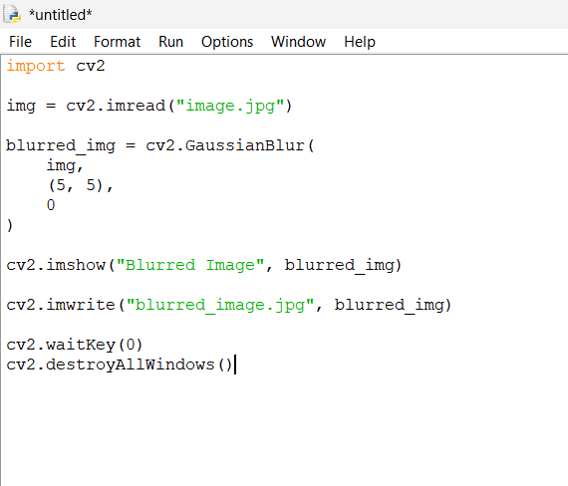
OUTPUT


